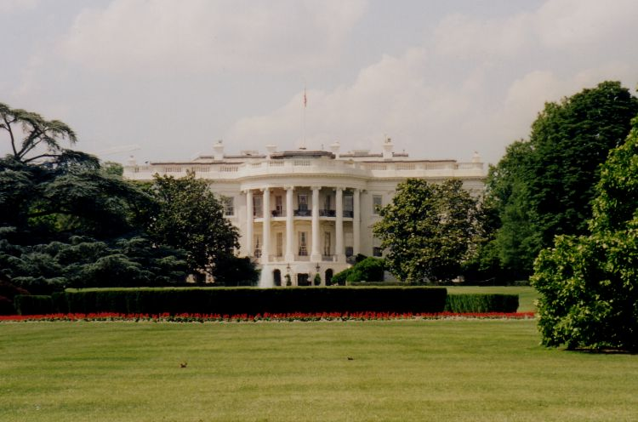

The Road to the White House

1) Bush/Cheney Re-Elect

Michael Gagliardo
Meagan Waszak
Ashley Hendrickson

2) Gen. Wes Clark

Danialle Coates
Brittany Fenske
Ali Yorra

3) Gov. Howard Dean

Joe Smolen
Teresa Przetocki
Amy Kiser
Edita Pojani
Christina Bush
Joe Roma
Julie Petrick (part-time)
Brandon Keith

- Sen. John Edwards

Ada Capellan
Nicole McConnell

5) Sen John Kerry

Jolene Bussiere
Liz Austin
Chad Thereau

6) Cong Dennis Kucinich

Dinara Newman

7) Sen. Joe Lieberman

Michena Georges

8) Gephardt

