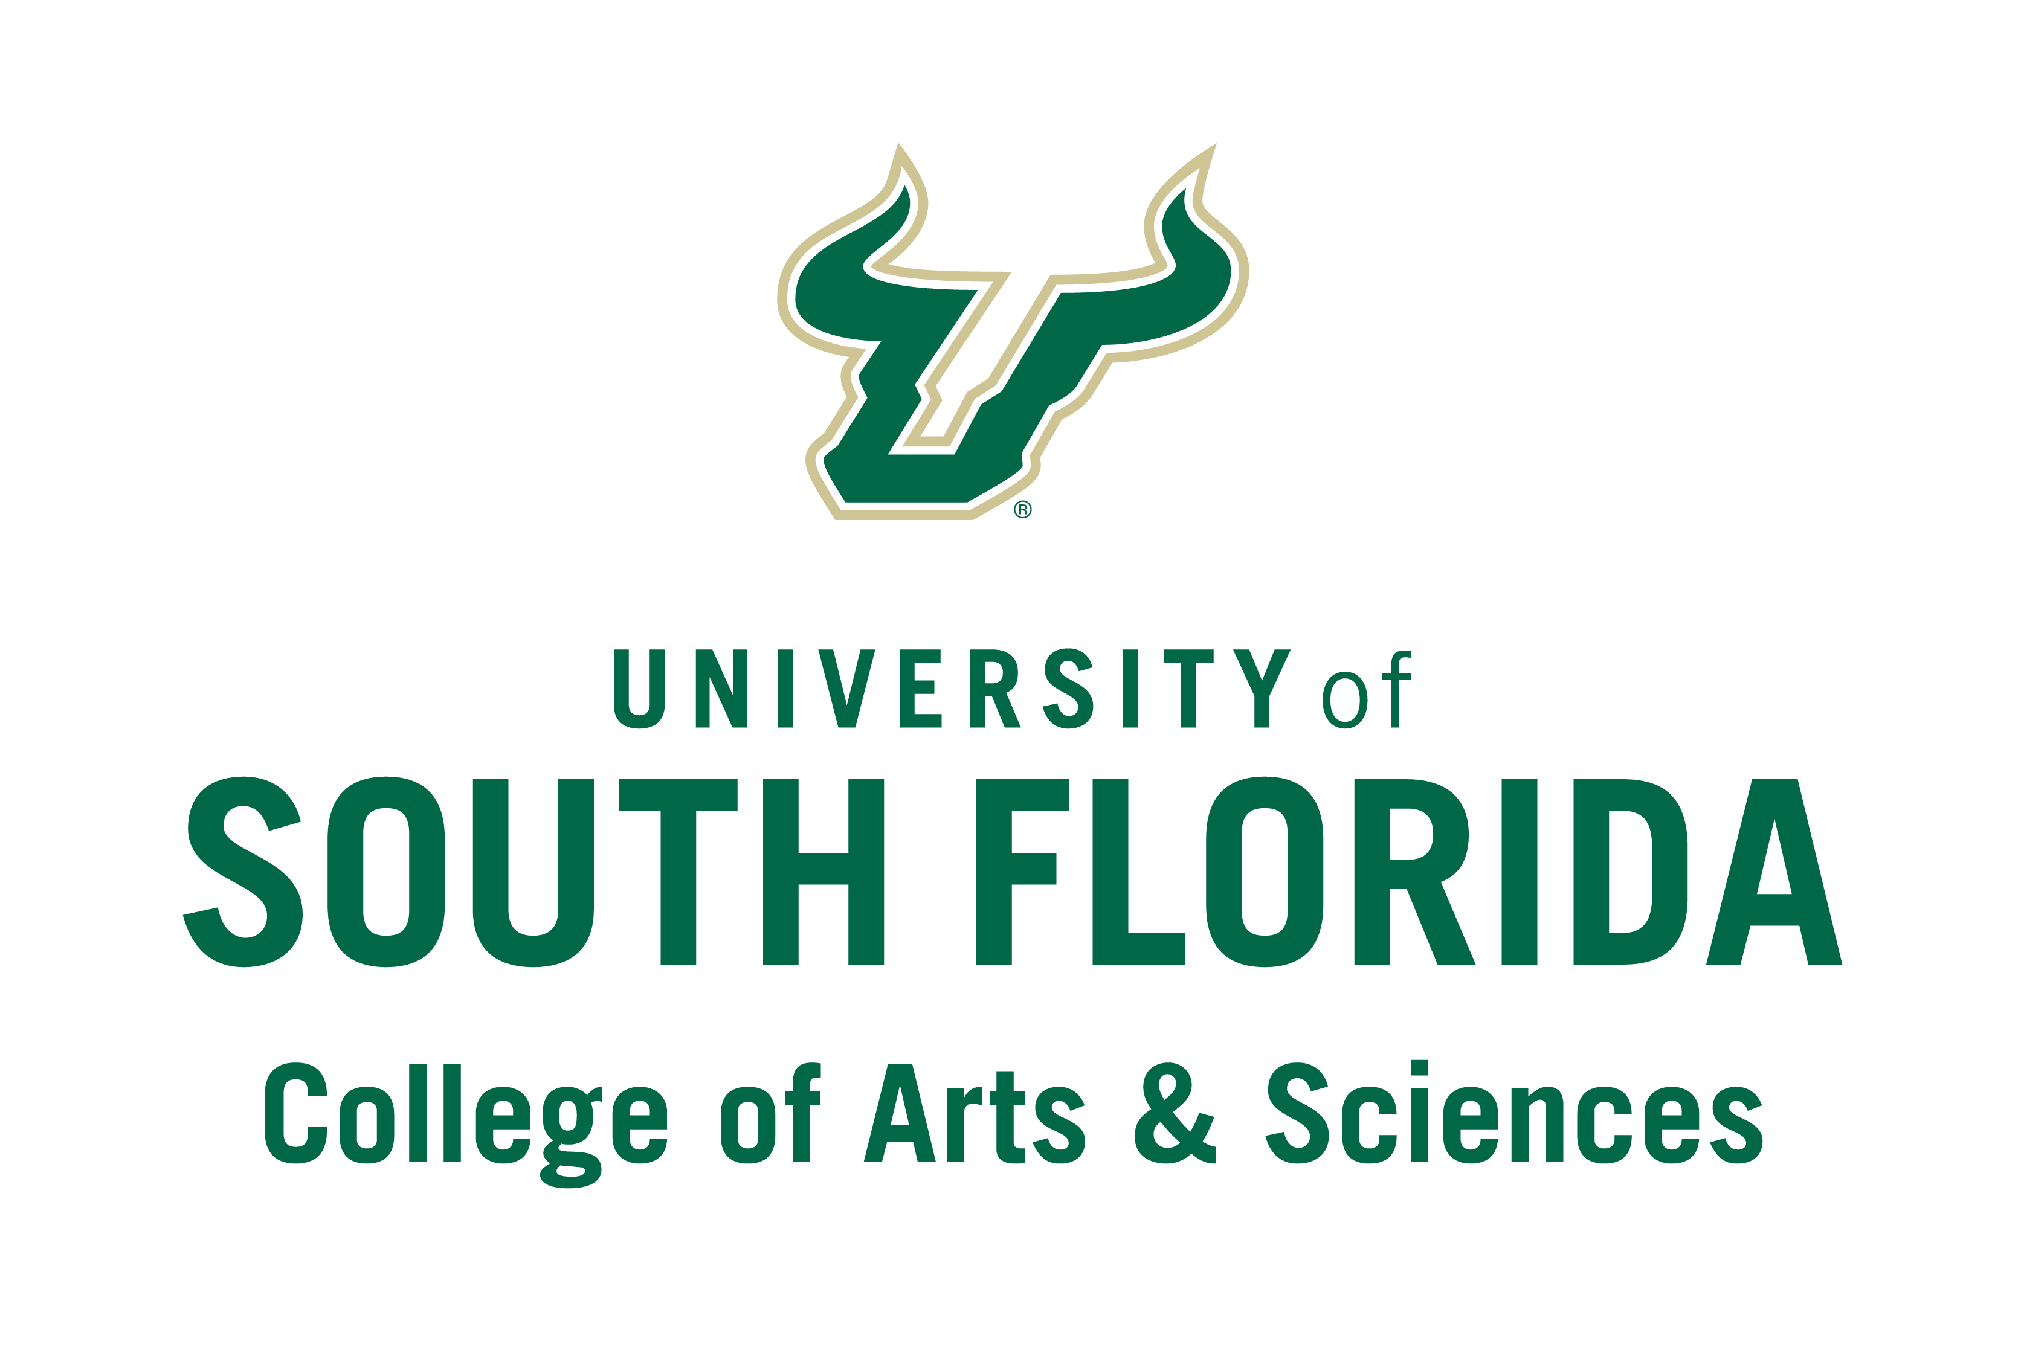

**CAS-ORS Large Collaborative or Center Grants: Proposal Planning Assistance**

***\* To be completed and sent to CAS-ORS -*** ***cvetromile@usf.edu***

**CAS Faculty Name:**

**Department and Faculty Rank:**

**USF Email Address:**

*So that CAS-ORS can best meet your proposal planning needs, please respond to the following inquiries:*

**Brief description of research interest and development:**

**Anticipated collaborative engagement (i.e., key personnel, etc.):**

**Funding Opportunities (note if you have explored specific grant funding opportunities, programs, directorates, etc.):**

**Other: Please provide any other information that you think might help the CAS-ORS team to assist with your proposal planning:**